TECHNICAL QUESTIONNAIRE |  |  |  |  |  | Variety denomination:  TYPE NAME ON page 1
 |  |  |  |  |  | Application:
 |  |  |  |  |  | (not to be filled in by the applicant)
TECHNICAL QUESTIONNAIRE
to be completed in connection with an application for plant breeders’ rights and NLI

1. Subject of the Technical Questionnaire
1.1 Botanical name |  |  | Solanum lycopersicum L.
1.2 Common name |  |  | Tomato
2. Applicant
Name
Address
Telephone No.
Fax No.
E-mail address
Breeder (if different from applicant)
3. Proposed denomination and breeder’s reference
Proposed denomination
(if available)

Breeder’s reference
#4. Information on the breeding scheme and propagation of the variety

4.1 Breeding scheme

(i) Inbred line [ ]
(ii) Hybrid [ ]
(iii) Open-pollinated variety [ ]
(iv) Other (provide details) [ ]

Variety resulting from:

4.1.1 Crossing

(a) controlled cross [ ]
(please state parent varieties)

(…………………..……………..…) x (……………..…………………..…)
female parent male parent

(b) partially known cross [ ]
(please state known parent variety(ies))

(…………………..……………..…) x (……………..…………………..…)
female parent male parent

(c) unknown cross [ ]

4.1.2 Mutation [ ]
(please state parent variety)

4.1.3 Discovery and development [ ]
(please state where and when discovered and how developed)

4.1.4 Other [ ]
(please provide details)

4.2 Method of propagating the variety

4.2.1 Seed-propagated varieties

(a) Self-pollination [ ]
(b) Cross-pollination
(i) population [ ]
(ii) synthetic variety [ ]
(c) Hybrid [ ]
(d) Other [ ]
(please provide details)

4.2.2 Vegetatively propagated varieties

(a) cuttings [ ]

(b) in vitro propagation [ ]

(c) other (state method) [ ]

4.2.3 Other [ ]
(please provide details)

5. Characteristics of the variety to be indicated (the number in brackets refers to the corresponding characteristic in Test Guidelines; please mark the note which best corresponds).

 | Characteristics |  |  |  |  |  | Example Varieties |  |  | Note
5.1  (2) | Plant: growth type
 | determinate |  |  |  |  |  | Campbell 1327, Prisca |  |  | 1 [ ]
 | indeterminate |  |  |  |  |  | Marmande VR,  Saint-Pierre,  San Marzano 2 |  |  | 2 [ ]
5.2  (10) | Leaf: type of blade
 | pinnate |  |  |  |  |  | Mikado, Pilot,  Red Jacket |  |  | 1 [ ]
 | bipinnate |  |  |  |  |  | Lukullus, Saint-Pierre |  |  | 2 [ ]
5.3  (19) | Peduncle: abscission layer
 | absent |  |  |  |  |  | Aledo, Bandera, Count, Lerica |  |  | 1 [ ]
 | present |  |  |  |  |  | Montfavet H 63.5, Roma |  |  | 9 [ ]
5.4  (21) | Fruit: green shoulder (before maturity)
 | absent |  |  |  |  |  | Felicia, Rio Grande, Trust |  |  | 1 [ ]
 | present |  |  |  |  |  | Daniela,  Montfavet H 63.5 |  |  | 9 [ ]
 | Characteristics |  |  |  |  |  | Example Varieties |  |  | Note
5.5  (26) | Fruit: size
 | very small |  |  |  |  |  | Cerise, Sweet 100 |  |  | 1 [ ]
 | very small to small |  |  |  |  |  |  |  |  | 2 [ ]
 | small |  |  |  |  |  | Early Mech, Europeel, Roma |  |  | 3 [ ]
 | small to medium |  |  |  |  |  |  |  |  | 4 [ ]
 | medium |  |  |  |  |  | Alphamech, Diego |  |  | 5 [ ]
 | medium to large |  |  |  |  |  |  |  |  | 6 [ ]
 | large |  |  |  |  |  | Carmello, Ringo |  |  | 7 [ ]
 | large to very large |  |  |  |  |  |  |  |  | 8 [ ]
 | very large |  |  |  |  |  | Erlidor, Lydia, Muril |  |  | 9 [ ]
5.6  (28) | Fruit: shape in longitudinal section  (see last page with illustrations)
 | flattened |  |  |  |  |  | Campbell 28, Marmande VR |  |  | 1 [ ]
 | oblate |  |  |  |  |  | Montfavet H 63.4, Montfavet H 63.5 |  |  | 2 [ ]
 | circular |  |  |  |  |  | Cerise, Moneymaker |  |  | 3 [ ]
 | oblong |  |  |  |  |  | Early Mech, Peto Gro |  |  | 4 [ ]
 | cylindric |  |  |  |  |  | Hypeel 244, Macero II, San Marzano 2 |  |  | 5 [ ]
 | elliptic |  |  |  |  |  | Alcaria, Castone |  |  | 6 [ ]
 | cordate |  |  |  |  |  | Valenciano |  |  | 7 [ ]
 | ovate |  |  |  |  |  | Dualrow, Soto |  |  | 8 [ ]
 | obovate |  |  |  |  |  | Duquesa, Estelle Rimone, Rio Grande |  |  | 9 [ ]
 | pyriform |  |  |  |  |  | Europeel |  |  | 10 [ ]
 | obcordate |  |  |  |  |  | Cuore del Ponente, Magno |  |  | 11 [ ]
 | Characteristics |  |  |  |  |  |  | Example Varieties |  |  | Note
5.7  (36) | Fruit: number of locules
 | only two |  |  |  |  |  |  | Early Mech, Europeel, San Marzano |  |  | 1 [ ]
 | two and three |  |  |  |  |  |  | Alphamech, Futuria |  |  | 2 [ ]
 | three and four |  |  |  |  |  |  | Montfavet H 63.5 |  |  | 3 [ ]
 | four, five or six |  |  |  |  |  |  | Raïssa, Tradiro |  |  | 4 [ ]
 | more than six |  |  |  |  |  |  | Marmande VR |  |  | 5 [ ]
5.8  (37) | Fruit: color (at maturity)
 | cream |  |  |  |  |  |  | Jazon, White Mirabell |  |  | 1 [ ]
 | yellow |  |  |  |  |  |  | Goldene Königin,  Yellow Pear |  |  | 2 [ ]
 | orange |  |  |  |  |  |  | Sungold |  |  | 3 [ ]
 | pink |  |  |  |  |  |  | Aichi First |  |  | 4 [ ]
 | red |  |  |  |  |  |  | Daniela, Ferline, Montfavet H 63.5 |  |  | 5 [ ]
 | brown |  |  |  |  |  |  | Ozyrys |  |  | 6 [ ]
 | green |  |  |  |  |  |  | Green Grape,  Green Zebra |  |  | 7 [ ]
5.9  (46) | Resistance to Meloidogyne incognita (Mi)
 | susceptible |  |  |  |  |  |  | Casaque Rouge |  |  | 1 [ ]
 | moderately resistant |  |  |  |  |  |  | Campeon, Madyta, Vinchy |  |  | 2 [ ]
 | highly resistant |  |  |  |  |  |  | Anabel, Anahu |  |  | 3 [ ]
5.10  (47) | Resistance to Verticillium sp. (Va and Vd) –Race 0
 | absent |  |  |  |  |  |  | Anabel, Marmande verte |  |  | 1 [ ]
 | present |  |  |  |  |  |  | Daniela, Marmande VR |  |  | 9 [ ]
 | Characteristics |  |  |  |  |  |  | Example Varieties |  |  | Note
5.11  (48.1) | Resistance to Fusarium oxysporum f. sp. lycopersici (Fol) Race 0  (ex 1)
 | absent |  |  |  |  |  |  | Marmande verte |  |  | 1 [ ]
 | present |  |  |  |  |  |  | Anabel, Marporum, Marsol |  |  | 9 [ ]
5.12  (48.2) | Resistance to Fusarium oxysporum f. sp. lycopersici (Fol) Race 1  (ex 2)
 | absent |  |  |  |  |  |  | Marmande verte |  |  | 1 [ ]
 | present |  |  |  |  |  |  | Motelle, Walter |  |  | 9 [ ]
5.13  (51.1) | Resistance to Tomato mosaic virus (ToMV) – Strain 0
 | absent |  |  |  |  |  |  | Monalbo, Moneymaker |  |  | 1 [ ]
 | present |  |  |  |  |  |  | Mobaci, Mocimor, Momor, Moperou |  |  | 9 [ ]
6. Similar varieties and differences from these varieties

Please use the following table and box for comments to provide information on how your candidate variety differs from the variety (or varieties) which, to the best of your knowledge, is (or are) most similar. This information may help the examination authority to conduct its examination of distinctness in a more efficient way.

Denomination(s) of variety(ies) similar to your candidate variety |  | Characteristic(s) in which your candidate variety differs from the similar variety(ies) |  |  | Describe the expression of the characteristic(s) for the similar variety(ies) |  |  |  | Describe the expression of the characteristic(s) for your candidate variety
E.g.: Daniela |  | Fruit: green shoulder |  |  | present |  |  |  | absent
Comments:

#7. Additional information which may help in the examination of the variety

7.1 In addition to the information provided in sections 5 and 6, are there any additional characteristics which may help to distinguish the variety?

Yes [ ] No [ ]

(If yes, please provide details)

7.2 Are there any special conditions for growing the variety or conducting the examination?

Yes [ ] No [ ]

(If yes, please provide details)

7.3 Other information

7.3.1 Resistance to pests and diseases (please specify races/strains if possible)

absent present not tested
a) Sensitivity to silvering (char. 45) [ ] [ ] [ ]

Resistance to :

b) Fusarium oxysporum f. sp. radicis-lycopersici (char. 49) [ ] [ ] [ ]

c) Fulvia fulva:
(i) Race 0 (char. 50.1) [ ] [ ] [ ]
(ii) Group A (char. 50.2) [ ] [ ] [ ]
(iii) Group B (char. 50.3) [ ] [ ] [ ]
(iv) Group C (char. 50.4) [ ] [ ] [ ]
(v) Group D (char. 50.5) [ ] [ ] [ ]
(vi) Group E (char. 50.6) [ ] [ ] [ ]

d) Tomato mosaic virus
(i) Strain 1 (char. 51.2) [ ] [ ] [ ]
(ii) Strain 2 (char. 51.3) [ ] [ ] [ ]

e) Phytophtora infestans (char. 52) [ ] [ ] [ ]

f) Pyrenochaeta lycopersici (char. 53) [ ] [ ] [ ]

g) Stemphylium spp. (char. 54) [ ] [ ] [ ]

absent present not tested

h) Pseudomonas syringae pv. tomato (char. 55) [ ] [ ] [ ]

i) Ralstonia solanacearum race 1 (char. 56) [ ] [ ] [ ]

j) Tomato yellow leaf curl virus (char. 57) [ ] [ ] [ ]

k) Tomato spotted wilt virus (char. 58) [ ] [ ] [ ]

l) Leveillula taurica (char. 59) [ ] [ ] [ ]

m) Oidium neolycopersici (char. 60) [ ] [ ] [ ]

n) Tomato torrado virus (char. 61) [ ] [ ] [ ]

o) Others (please specify)

7.3.2 Special conditions for the examination of the variety

- Type of culture
- under glass [ ]

- in the open [ ]

- Main use
- fresh market or garden [ ]

- industrial processing (indicate type) [ ]

- pot plant [ ]

- other [ ]

8. Authorization for release

(a) Does the variety require prior authorization for release under legislation concerning the protection of the environment, human and animal health?

Yes [ ] No [ ]

(b) Has such authorization been obtained?
Yes [ ] No [ ]

If the answer to (b) is yes, please attach a copy of the authorization.

9. Information on plant material to be examined or submitted for examination.

9.1 The expression of a characteristic or several characteristics of a variety may be affected by factors, such as pests and disease, chemical treatment (e.g. growth retardants or pesticides), effects of tissue culture, different rootstocks, scions taken from different growth phases of a tree, etc.

9.2 The plant material should not have undergone any treatment which would affect the expression of the characteristics of the variety, unless the competent authorities allow or request such treatment. If the plant material has undergone such treatment, full details of the treatment must be given. In this respect, please indicate below, to the best of your knowledge, if the plant material to be examined has been subjected to:

(a) Microorganisms (e.g. virus, bacteria, phytoplasma) Yes [ ] No [ ]

(b) Chemical treatment (e.g. growth retardant, pesticide) Yes [ ] No [ ]

(c) Tissue culture Yes [ ] No [ ]

(d) Other factors Yes [ ] No [ ]

Please provide details for where you have indicated “yes”.

……………………………………………………………

10. I hereby declare that, to the best of my knowledge, the information provided in this form is correct:

Applicant’s name

Signature Date

[End of document]

5.6
Ad. 28: Fruit: shape in longitudinal section

 |  | ← broadest part →
 |  | (below middle) | at middle | (above middle)

broad (compressed) ← width (ratio length/width) → narrow (elongated) |  | 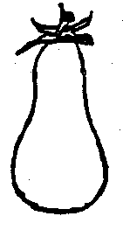 | 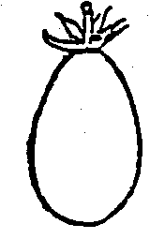 | 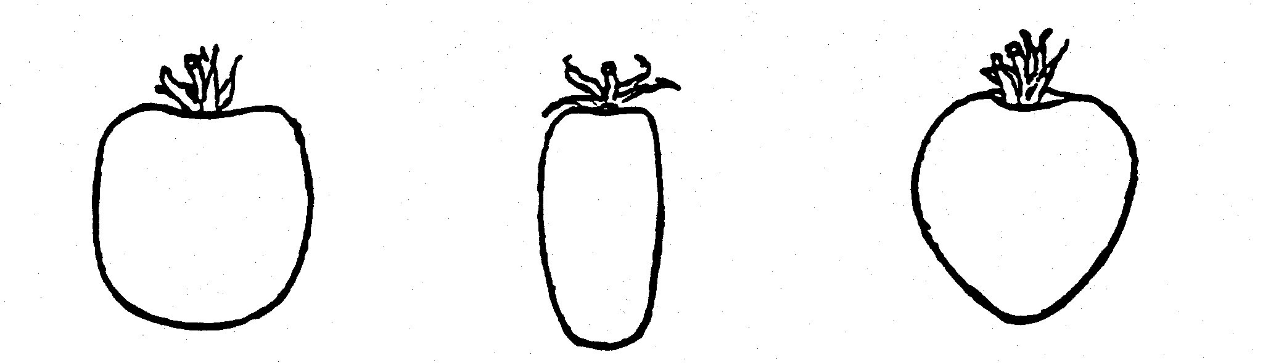 | 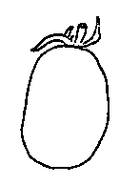 | 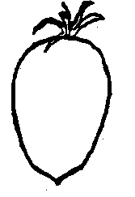
 |  | 10 | 8 | (parallel)  5 | (rounded)  6 | 9 | 7
 |  | pyriform | ovate | cylindric | elliptic | obovate | cordate
 |  | 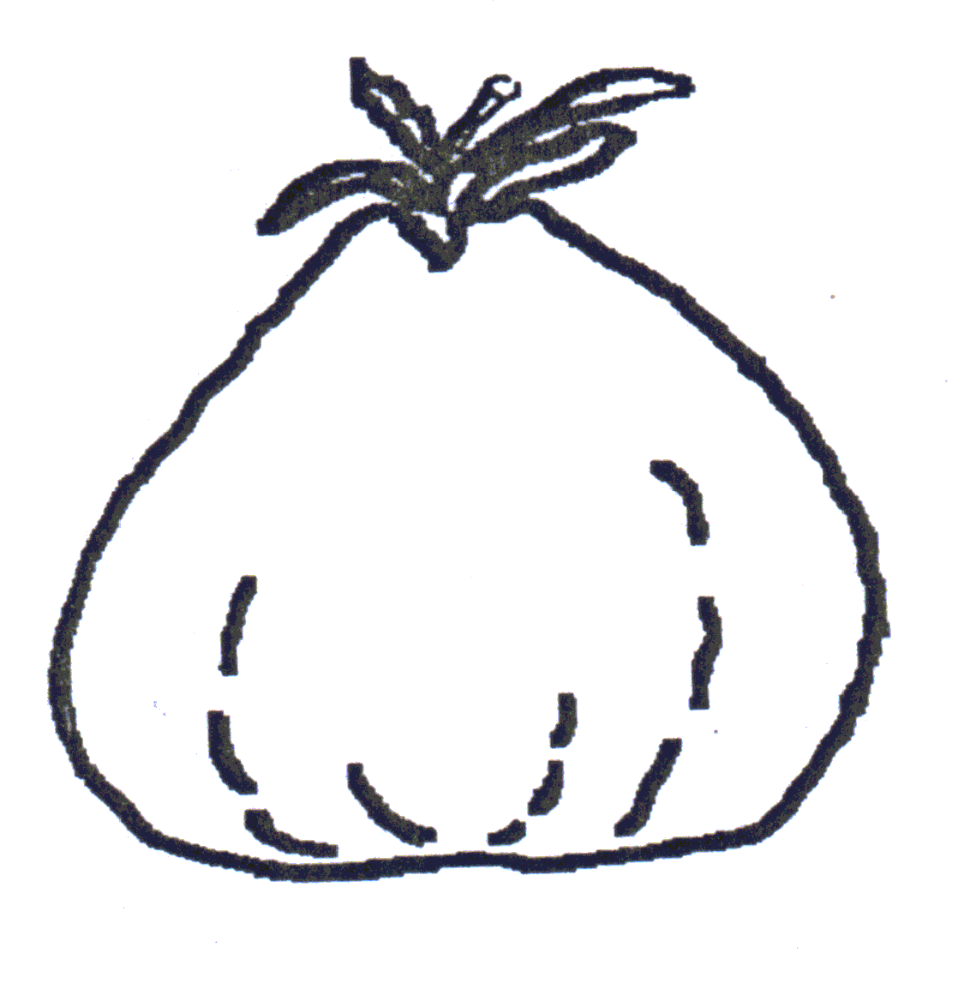 |  |  | 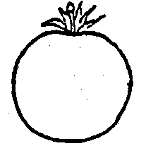
 |  | 11 |  | (parallel)  4 | (rounded)  3
 |  | obcordate |  | oblong | circular
 |  |  |  | 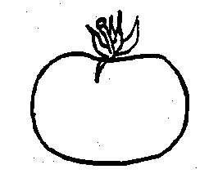
 |  |  |  | 2
 |  |  |  | oblate
 |  |  |  | 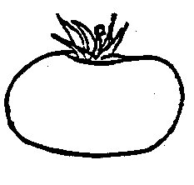
 |  |  |  | 1
 |  |  |  | flattened

The apex is considered to be the part that is farthest from the peduncle end.

# Authorities may allow certain of this information to be provided in a confidential section of the Technical Questionnaire.
# Authorities may allow certain of this information to be provided in a confidential section of the Technical Questionnaire.

